Reading for Pleasure: Review your practice
South Yorkshire Reading Guarantee
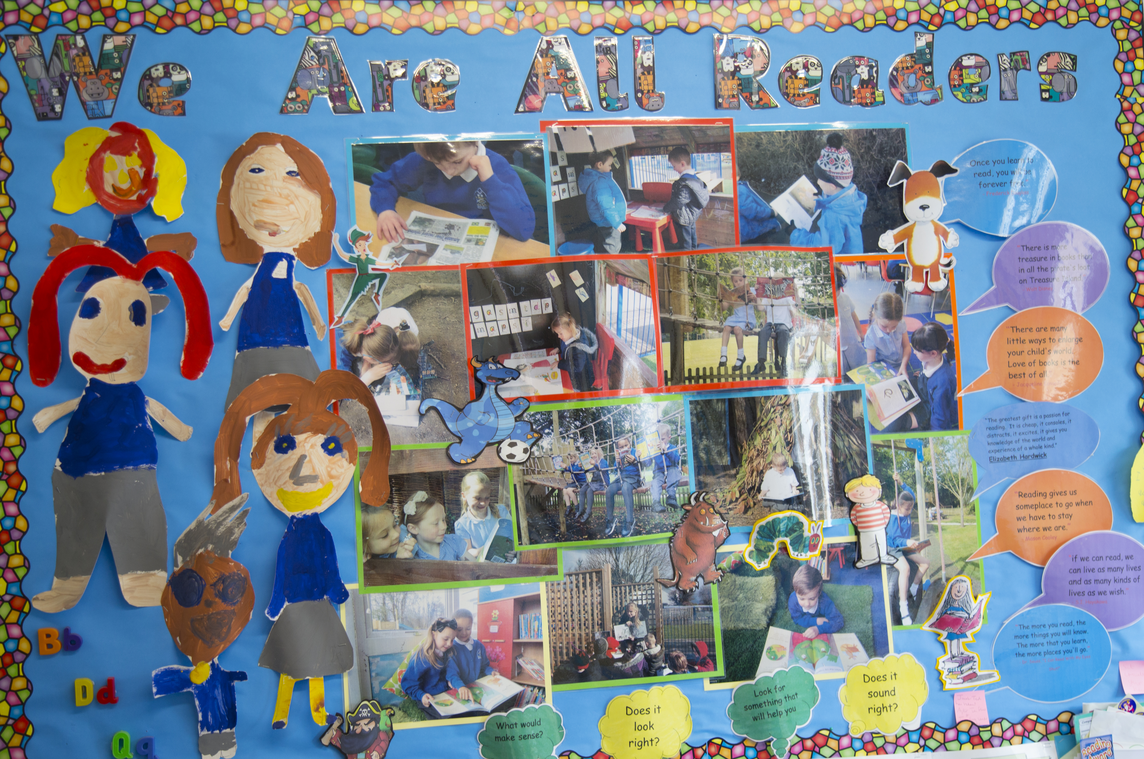

This self-review document is designed to help you consider your practice with regard to reading for pleasure. It is organised around key themes which, research evidence indicates, influence teachers’ capacity to effectively develop children’s engagement as readers- readers who like reading, who chose to read, and who want to talk about what they are reading with others (Cremin et al., 2014).

Research evidence shows that the will to read positively influences the skill and that there is an association between choosing to read in your own time and later academic success (Sullivan and Brown, 2015). The habit of reading in childhood enriches children’s vocabulary, their wider knowledge of the world, and their imaginations. It impacts upon their life chances. To be enticed to read and supported as a reader is a fundamental right of every child (International Literacy Association, 2018).
- Teachers’ knowledge of children’s literature
Significant staff knowledge of children’s literature and other texts is the cornerstone of an effective RfP pedagogy and essential subject knowledge.
- Name three authors whose work you value
……………………………………………………………………………………………………………………………………………..
……………………………………………………………………………………………………………………………………………..
……………………………………………………………………………………………………………………………………………..

- Name three picture book illustrators whose work you value
……………………………………………………………………………………………………………………………………………..
……………………………………………………………………………………………………………………………………………..
……………………………………………………………………………………………………………………………………………..

- Name three poets whose work you value
……………………………………………………………………………………………………………………………………………..
……………………………………………………………………………………………………………………………………………..
……………………………………………………………………………………………………………………………………………..
- Children’s reading practices
Teachers’ knowledge of children’s reading preferences and practices, both at home and at school, is essential in order to support their journeys as individual readers.
- List three different children in your class
……………………………………………………………………………………………………………………………………………..
………………………………………………………… and …………………………………………………………………………..

- Rate your knowledge of each child’s reading habits and preferences in school
(Rate this on a scale of 1‐6 with 6 being the highest – circle one number)

1 2 3 4 5 6

- Rate your knowledge of their reading habits and preferences out-of- school
(Rate this on a scale of 1‐6 with 6 being the highest – circle one number)

1 2 3 4 5 6

- How do you find out about children’s attitudes to reading in your class and school?
……………………………………………………………………………………………………………………………………………..
……………………………………………………………………………………………………………………………………………..

- How often do you talk to parents about the books children like to read at home?

Regularly □ Sometimes □ Rarely □ Never □

- How often do you seek out specific books or other reading materials for and with particular children?

Regularly □ Sometimes □ Rarely □ Never □
- Reading for pleasure pedagogy
An effective RfP pedagogy encompasses planned time for reading aloud, independent reading, book talk and recommendations in the context of a social reading environment. These fourfold strands are highly interdependent and need to be deployed in a responsive manner according to need.
Reading for pleasure pedagogy: Social reading environments
Social reading environments in and around school are key to creating a strong reading culture. Successful environments invite readers to engage and share the pleasures of reading.

- Think of your classroom, what three key messages does your environment convey about reading?
……………………………………………………………………………………………………………………………………………..
……………………………………………………………………………………………………………………………………………..
……………………………………………………………………………………………………………………………………………..

- Rate your knowledge about the children’s reading networks/reader relationships, who they read/talk with about reading.
(Rate this on a scale of 1‐6 with 6 being the highest – circle one number)

1 2 3 4 5 6

- Does your class library include a range of genres, age-appropriate tempting texts that reflect children’s diverse realities? Do these include:

Picture books □ Novels □
Poetry □ Non-fiction □
Magazines and comics □ Graphic novels □

Reading for pleasure pedagogy: Reading aloud

High quality reading aloud for pleasure is a core part of RfP pedagogy, in addition to reading aloud as part of literacy teaching. Its purpose and nature is subtly different.

- On average, how much time per day do you allocate to reading aloud stories or other books to the class?

- minutes □ 20 minutes □ 10 minutes □ 5 minutes or less □

- Who chooses what you read aloud?

- You always □
- You mostly and occasionally the children □
- You share choices and decide with the children □

- What in your view are the core reasons for reading aloud to children?
(Rank order 1‐5, 1 being the most important and 5 the least)

- Widening children’s vocabulary □
- Providing a role model of expressive reading □
- Enjoyment of texts beyond their ability
- Motivating wider free-choice reading □
- Building ‘books in common’ that all your class share and recommend □

Reading for pleasure pedagogy: Independent reading time

Children need time and space to read, and focused support for making informed choices from a range of texts that tempt.

- How frequently do you set aside time for children to read independently?

Daily □ Weekly □ Occasionally (ad hoc) □ Never □

- How often do children choose what they are reading?
Regularly □ Sometimes □ Rarely □ Never □

18. How often do you encourage children to talk informally about what they have chosen to read?

Regularly □ Sometimes □ Rarely □ Never □

Reading for pleasure pedagogy: Informal book talk and recommendations

Talking about texts reader to reader is essential to all literacy teaching, but this reader to reader talk is more informal, often spontaneous, and includes reciprocal book recommendations between children and teachers.

- How often do you informally chat about books with children (excluding reading scheme/ phonically decodable texts that are not being studied in primary literacy)?

Regularly □ Sometimes □ Rarely □ Never □

- How often do you observe children talking informally about books or other texts with their peers?

Regularly □ Sometimes □ Rarely □ Never □

- How often do you make specific tailored recommendations to particular children?

Regularly □ Sometimes □ Rarely □ Never □

- Reading Teachers: Teachers who read and readers who teach

Reading Teachers are teachers who read and readers who teach and who explore the experience of being a reader and what this might mean for their practice as an educator.

- How often do the children in your class see you reading for pleasure?

Regularly □ Sometimes □ Rarely □ Never □

- How do you think the children in your class view you as a reader? (Tick one)

- As an avid, enthusiastic reader who loves reading □
- As a keen reader who reads when time allows □
- As someone who may be a reader □
- I don’t think they will have considered this □
- Someone who is required to read because they are the teacher □

- To what extent do you share your reading life with children in school? Do you share:
Often Sometimes Rarely Never

- Your interest in and attitude to reading □ □ □ □

- Aspects of your life history as a reader □ □ □ □

- The range of material you currently choose to read □ □ □ □

- Your practices and habits as an adult reader □ □ □ □

- Your views and emotional responses to the texts you read □ □ □ □

- Do children see you chatting about what you are reading with other teachers/adults in earshot of the children?

Regularly □ Sometimes □ Rarely □ Never □

E. Reading communities
Communities of engaged readers are characterised by interaction around reading and reciprocal relationships between children and adults. Such communities exist within and beyond school, take time to build and need ongoing support.
26. To what extent do you feel you have developed a two-way partnership with parents that enables them to understand the importance of children choosing to read, and of reading to and with their children?
(Rate this on a scale of 1‐6 with 6 being the highest – circle one number)

- 2 3 4 5 6

- Rate the strength of your class reading community. Is there energy, passion and excitement around choice-led reading on the part of all children?

Regularly □ Sometimes □ Rarely □ Never □

- Looking back across this review, which area do you feel is strongest and which do you want to develop to support children’s reading for pleasure?
Strongest………………………………………………………………………………………………………………………………
……………………………………………………………………………………………………………………………………………..
Aspects to develop ………………………………………………………………………………………………………………
……………………………………………………………………………………………………………………………………………..

Support for your next steps

For ideas on how to develop your reading for pleasure practice, individually and as a whole school, see the Open University’s research-informed website. There you can find ideas for action, focused audits, classroom clips, filmed interviews, more research details and over 400 examples of teachers’ practice under each of the key areas noted above https://ourfp.org/

